VCS Task
Establish a new directory, populate it with script files, initiate an empty repository on GitHub, convert the local directory into a Git repository, and link it to GitHub for pushing the code into the repository.Perform merge, rebase, stash commands in following github repo.

Created the empty repository on GitHub.
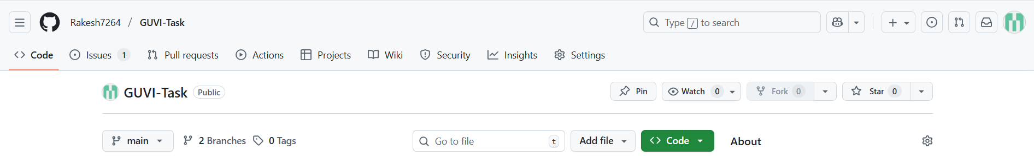
Clone the Git repo in the ubuntu machine.
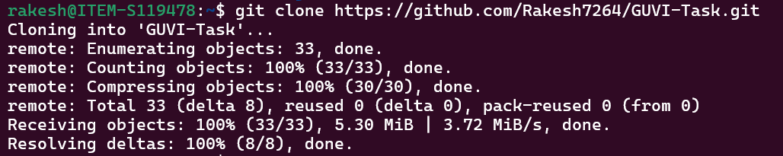
Created the sample script file.
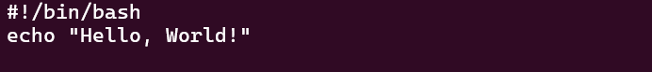
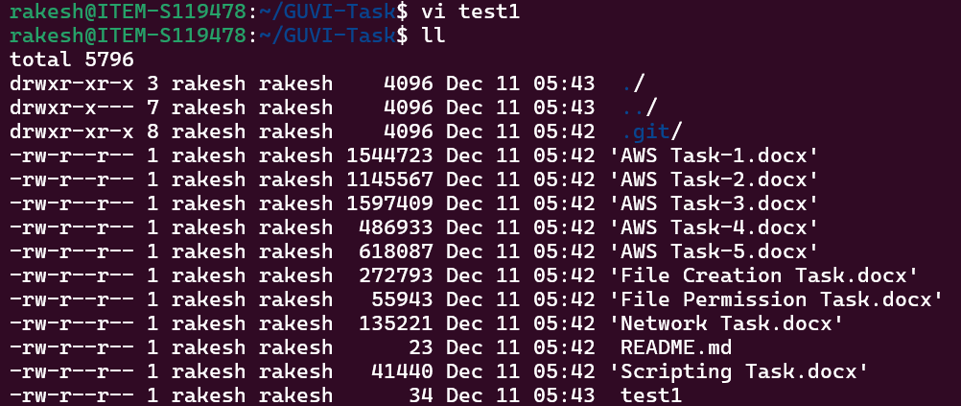

Created the “feature2” branch.
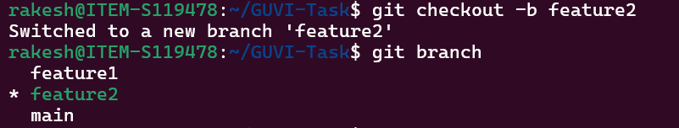
Check the status of the “test1” file. Which is in the unstage.
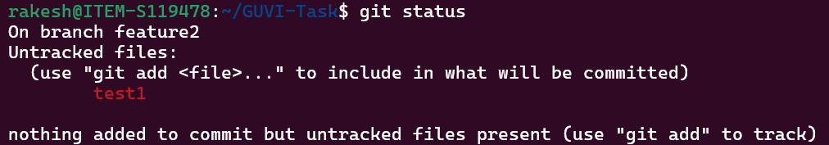
Add the “test1” file from unstage to stage.
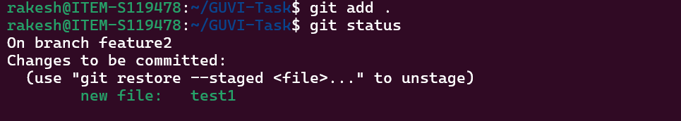
Commit the change in the local.
Push the change to the git repo to the “feature2” branch.
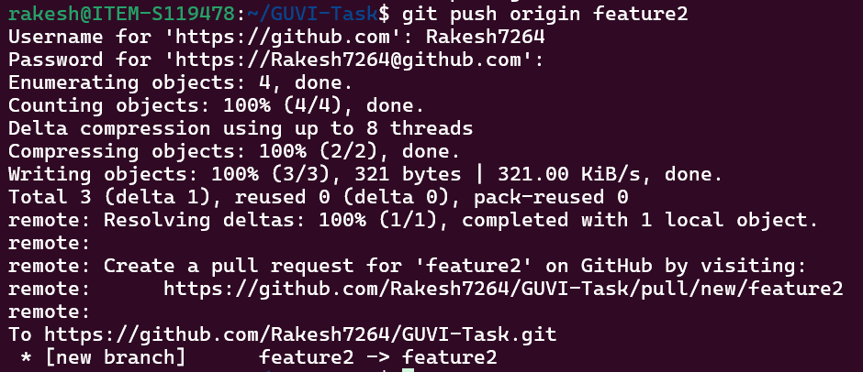

Merge - Used to combine changes from one branch into another, creating a merge commit
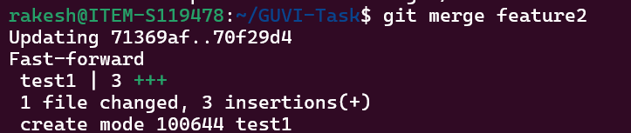
Rebase- Rewrites commit history by placing your branch’s commits on top of another branch.
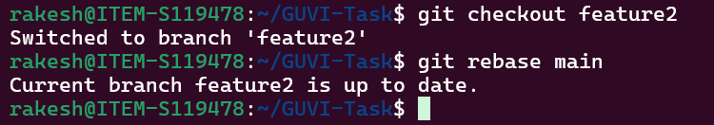
Stash - Temporarily saves uncommitted changes so you can switch branches without committing.
